1. The mean center of this point pattern is (6006712.929320’, 2107011.623561’) and the standard distance (standard distance deviation) is 10705.07’.
2. The mean center represents the average latitude and longitude of the point pattern, while the standard distance measures the amount of dispersion in the point pattern from the mean center. The smaller the standard distance, the more clustered the point pattern.
3. The median center is (6008067.99995’, 2110337.50840’), slightly northeast of the median center.
4. The median center differs from the mean center because points are mostly clustered in the center and northeast, while there are many more dispersed points to the south which brings the mean farther south.
5. The standard deviational ellipse’s X-axis length is 16574.54’ and its Y-axis length is 25339.16’. The clockwise angle of Y-axis rotation is 9.851157 degrees and the ratio of long to short axis is 1.5288. The ratio of long to short axis means that the Y-axis is much longer, meaning that the point pattern is dispersed latitudinally (more from north to south than east to west).

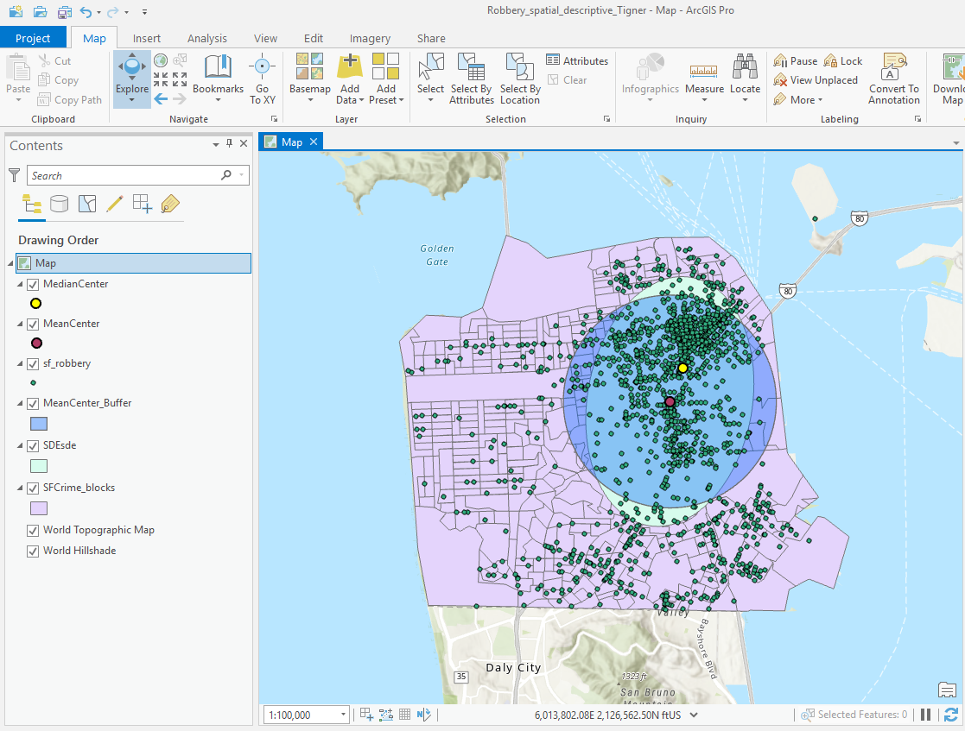

1. The Mean Nearest Neighbor Distance is 124.71’. The expected nearest neighbor under the assumption of a random point pattern is 381.4380’. The nearest neighbor index is 0.32694, meaning that the point pattern is very clustered. A nearest neighbor index close to 0 indicates clustering, while values close to 1 indicate randomness and values near 2.149 indicates dispersion.

**Extension**

1. The mean center is (6006853.575491’, 2108164.656843’). The standard distance is 9836.22’.

3. The median center is (6008513.41440’, 2111920.47369’). Relative to the mean center

the median center is northeast.

5. The standard deviational ellipse has an X-axis length of 17907.82’ and a Y-axis length of

21291.29’. The clockwise angle of the Y-axis rotation is 5.194421 degrees. The ratio of

long to short axis is 1.1889, indicating that the dispersion is more spread from latitude

than longitude by about 20%.

6.

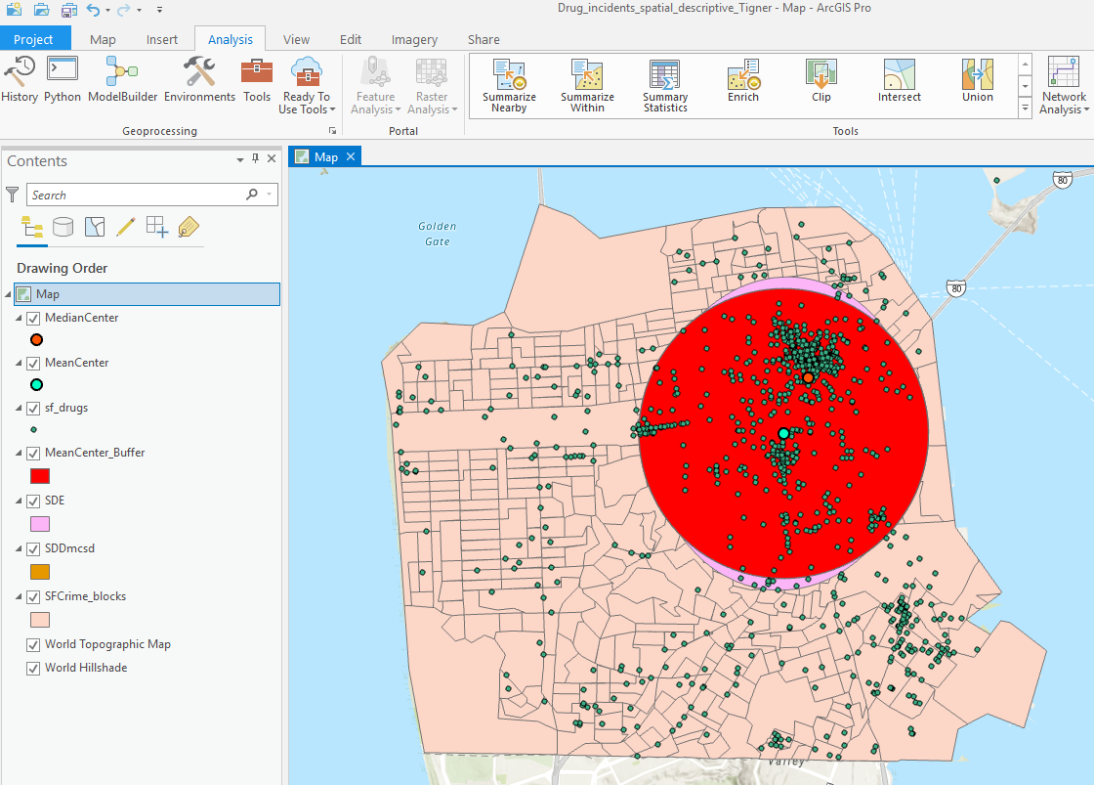

1. The Mean Nearest Neighbor Distance is 20.4577’. The expected nearest neighbor under the assumption of a random point pattern is 320.2263’. The nearest neighbor index is 0.06389, meaning that the point pattern is very clustered. A nearest neighbor index close to 0 indicates clustering, while values close to 1 indicate randomness and values near 2.149 indicates dispersion.

9. The mean center for robberies is (6006712.929320’, 2107011.623561’) and

(6006853.575491’, 2108164.656843’) for drug incidents. The median center is

(6008067.99995’, 2110337.50840’) for robberies and is (6008513.41440’,

2111920.47369’) for drug incidents. Both of these points are in close proximity for both

of the datasets. The standard is 10705.07’ for robberies and 9836.22’ for drug incidents,

with robberies being slightly more dispersed. The ratio of long to short axis is greater

than 1.0 for both datasets, indicating that robberies and drug incidents are both

dispersed more latitudinally than longitudinally. Both datasets are very clustered, but

drug incidents are much more clustered (shown by a lower nearest neighbor index). The

similarities are likely due to a correlation between robbery and drug use, with one

increasing the likelihood of the other or vice versa. Both crimes tend to cluster in the

same area, but robberies are more dispersed. This is likely because drug use happens in

people’s homes (more concentrated in certain areas due to poverty and other factors)

while robberies occur in a relatively more widespread manner.